Unified Modeling Language Diagrams
  - The unified modeling language allows the software engineer to express an analysis model using the modeling notation that is governed by a set of syntactic semantic and pragmatic rules.
  - A UML system is represented using five different views that describe the system from distinctly different perspective. Each view is defined by a set of diagram, which is as follows.
  - User Model View
    - This view represents the system from the users perspective.
    - The analysis representation describes a usage scenario from the end-users perspective.
  - Structural model view
◆ In this model the data and functionality are arrived from inside the system.
◆ This model view models the static structures.
  - Behavioral Model View
◆ It represents the dynamic of behavioral as parts of the system, depicting the interactions of collection between various structural elements described in the user model and structural model view.
  - Implementation Model View
  - In this the structural and behavioral as parts of the system are represented as they are to be built.
Environmental Model View
In this the structural and behavioral aspects of the environment in which the system is to be implemented are represented.
UML is specifically constructed through two different domains they are
  - UML Analysis modeling, which focuses on the user model and structural model views of the system
  - UML design modeling, which focuses on the behavioral modeling, implementation modeling and environmental model views.

INTRODUCTION TO THE UNIFIED MODIFIED LANGUAGE
Building a model for a software system prior to its construction is as essential as having a blueprint for building a large building. Good models are essential for communication among project teams. As the complexity of the systems increases, so does the importance of good modeling techniques.

A modeling language must include:

- Model elements- fundamentally modeling concepts and semantics.

Notation-visual rendering of model elements

Guidelines-expression of usage within trade

The use of visual notation to represent or model a problem can provide us several benefits relating to clarity, familiarity, maintenance, and simplification. The main reason for modeling is the reduction of complexity.

The Unified Modeling Language (UML) is a set of notations and conventions used to describe and model an application. The UML is intended to be a universal language for modeling systems, meaning that it can express models of many different kinds and purposes, just as a programming language or a natural language can be used in different ways.

A “model” is an abstract representation of a system , constructed to understand the system prior to building or modifying it. The term “system” is used here in a broad sense to include any process or structure. For example, the organizational structure of a corporation , health services, computer software, instruction of any sort (including computers) , the national economy, and so forth all would be termed “systems”.

The unified modeling language is a language for specifying, constructing, visualizing, and documenting the software system and its components. The UML is a graphical language with sets of rules and semantics. The rules and semantics of a model are expressed in English, in a form known as “object constraint language”(OCL).OCL is a specification language that uses simple logic for specifying the properties of a system.

The UML is not intended to be a visual programming language in the sense of having all the necessary visual and semantic support to replace programming languages. However, the UML does have a tight mapping to a family of object-oriented languages, so that you can get the best of both worlds.

The primary goals in the design of the UML were as follows:

- Provide users ready-to-use, expensive visual modeling languages so they can develop and exchange meaningful models.

- Provide extendibility and specialization mechanisms to extend the core concepts.

- Be independent of particular programming languages and development process.

- Provide a formal basis for understanding the modeling language.

- Encourage the growth of the OO tools market.

- Support higher level development concepts.

- Integrate best practices and methodologies.

UML is a language used to:

- “Visualize” the software system well-defined symbols. Thus a developer or tool can unambiguously interpret a model written by another developer, using UML
- “Specify the software system and help building precise, unambiguous and complete models.
- “Construct” the models of the software system that can directly communicate with a variety of programming languages.
- “Document” models of the software system during its development stages.

Architectural views and diagrams of the UML

The UML Meta model elements are organized into diagrams. Different diagrams are used for
different purposes depending on the angle from which you are viewing the system. The different views are called “architectural views”. Architectural views facilitate the organization of knowledge, and diagrams enable the communication of knowledge. Then knowledge itself is within the model or set of models that focuses on the problem and solution. The architectural views and their diagrams are summarized below:

- The “user model view” encompasses a problem and solution from the preservative of those individuals whose problem the solution addresses. The view presents the goals and objectives of the problem owners and their requirements of the solution. This view is composed of “use case diagrams”. These diagrams describe the functionality provided by a system to external interactors. These diagrams contain actors, use cases, and their relationships.

  - “Class diagrams” describe the static structure of a system, or how it is declared rather than how it behaves. These diagrams contain classes and associations.
  - “object diagrams” describe the static structure of a system at a particular time during its life. These diagrams contain objects and links.

- The “behavioral model view” encompasses the dynamic or behavioral aspects of a problem and solution. The view is also known as the dynamic, process, concurrent or collaborative view. This view is composed of the following diagrams:

- “Sequence diagrams” render the specification of behavior. These diagrams describes the behavior provided by a system to interactors. These diagrams contain classes that exchange messages with in an interaction arranged in time sequence. In generic form, These diagrams describe a set of message exchange sequences among a set of classes. In instance form(scenarios), these diagrams describe one actual message exchange sequence among objects of those classes.
- “Collaboration diagrams” render how behavior is realized by components with in a system. These diagrams contain classes, associations, and their message exchanges with in a collaboration to accomplish a purpose. In generic form, these diagrams describe a set of classes and associations involved in message exchange sequences. In instance form(scenarios), these diagrams describe a set of objects of those classes links confirming to the associations, and one actual message exchange sequence that inconsistent with the generic form and uses those objects and links.
- “State chart diagrams” render the states and responses of a class participating in behavior, and the life cycle of an object. These diagrams describe the behavior of a class in response to external stimuli.
- “Activity diagrams” render the activities of a class participating in behavior. These diagrams describe the behavior of a class in response to internal processing rather than external events. Activity diagrams describe the processing activities with in a class.
- The “Implementation model view” encompasses the structural and behavioral aspects of the solution’s realization. This view is also known as the component or development view and is composed of “component diagrams”. These diagrams describe the organization of and dependencies among software implementation components. These diagrams contain components and their relationships.
- The “Environment model view” encompasses the structural and behavioral aspects of the domain in which a solution must be realized. This view is also known as the deployment or physical view. This view is composed of “deployment diagrams”. These diagrams describe the configuration of processing resources elements and the mapping of software implementation components onto them. These diagrams contain nodes, components and their relationships.

UML DIAGRAMS

Every complex system is best approached through a small set of nearly independent views of a model; no single viewer is sufficient. Every model may be expressed at different levels of fidelity. The best models are connected to reality. The UML defines nine graphical diagrams.

- Class diagram
- Use-case diagram
3. Sequence diagram
4. Collaboration diagram
5. Activity diagram

Administrator Functionalities

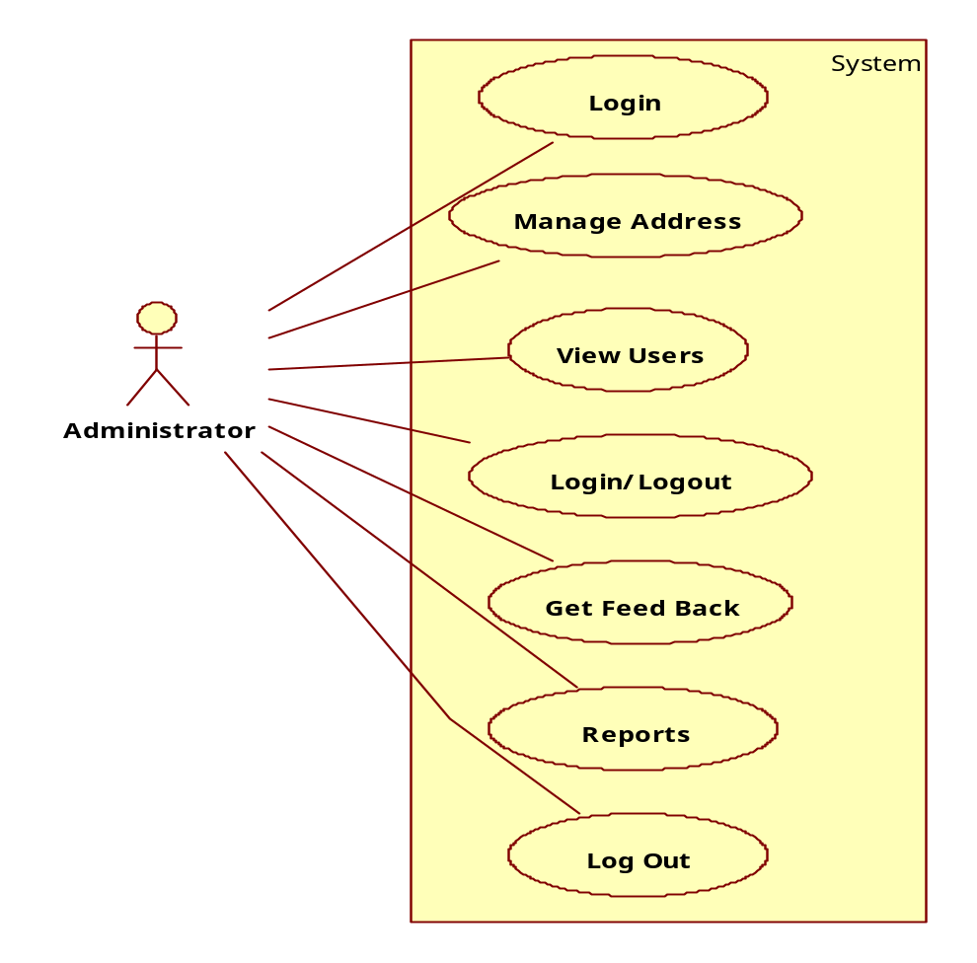
User Activities

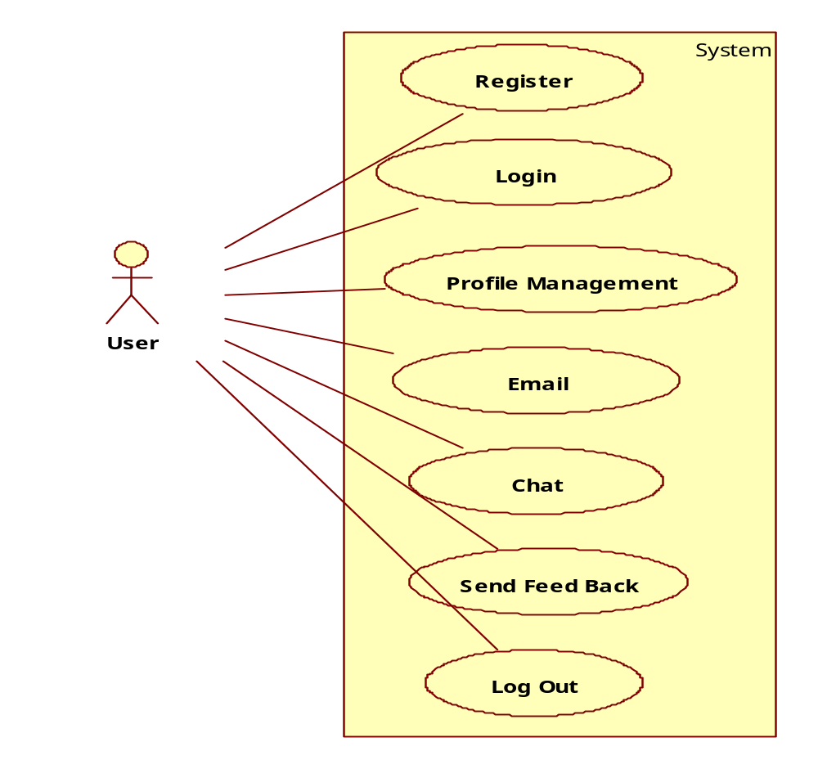
Sequence Diagrams

Admin Login

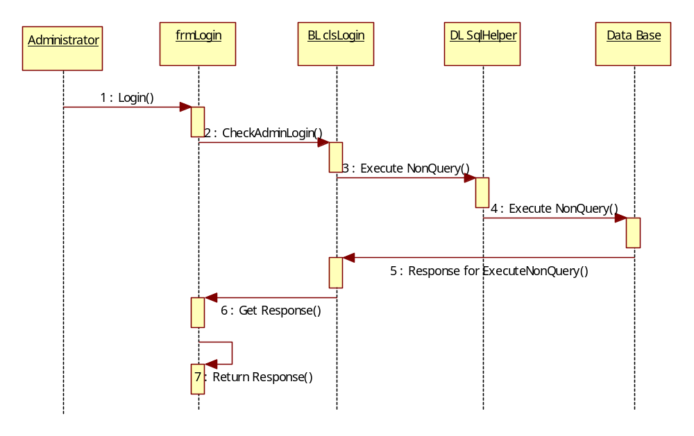
Admin Add New Country Details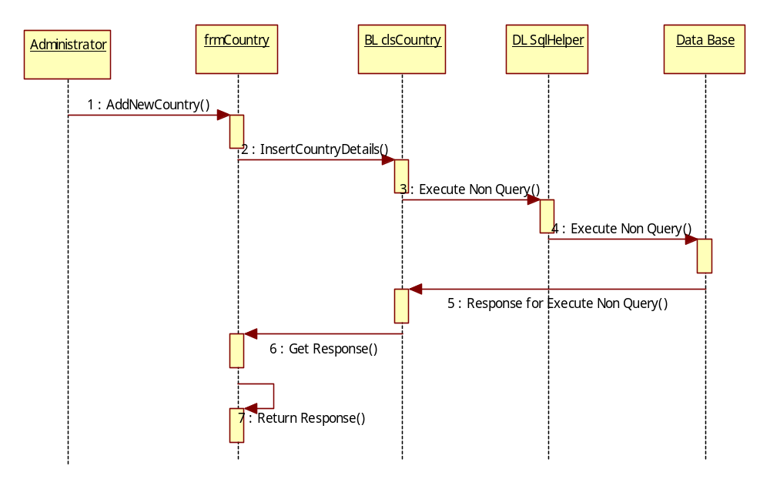
Admin Add New State Details
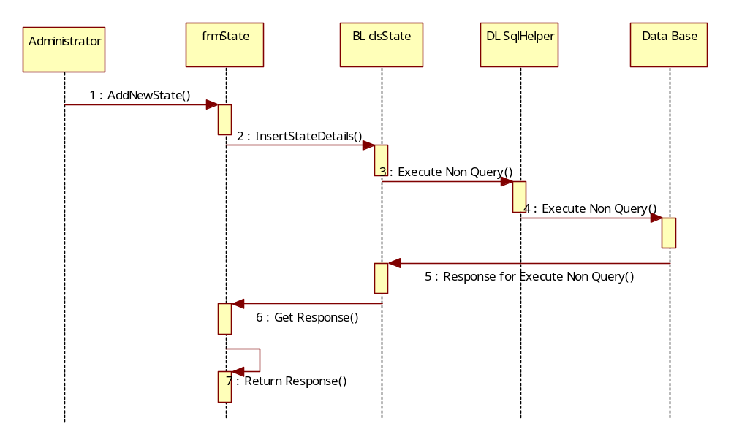
Admin Track User Login Details

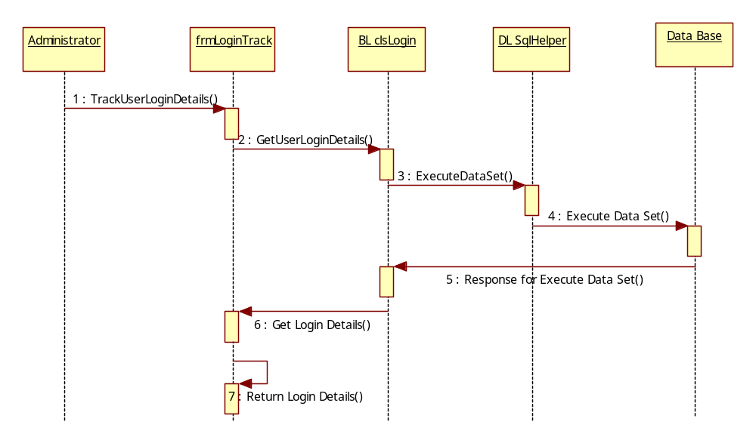
Admin Track User Log Out Details
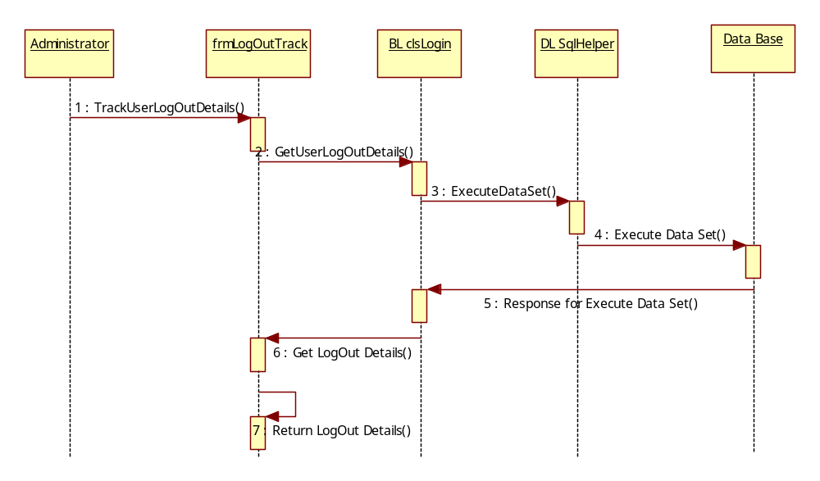
User Login
User
Login
BL Login
Data Base
DL SQlHelper
1 : Login()
2 : Validate Data()
5 : Response for Execute NonQuery()
7 : Show Result
3 : Execute NonQuery()
4 : Execute NonQuery()
6 : Get Response

User Activities

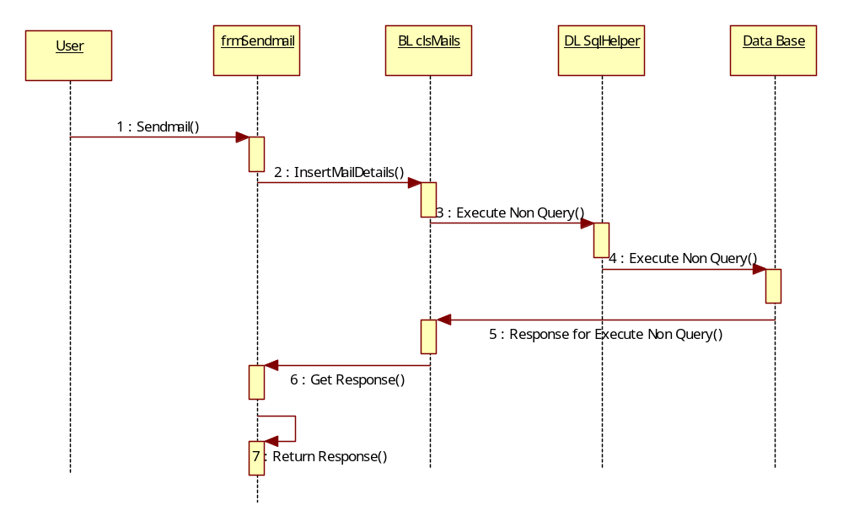
User Chat Details
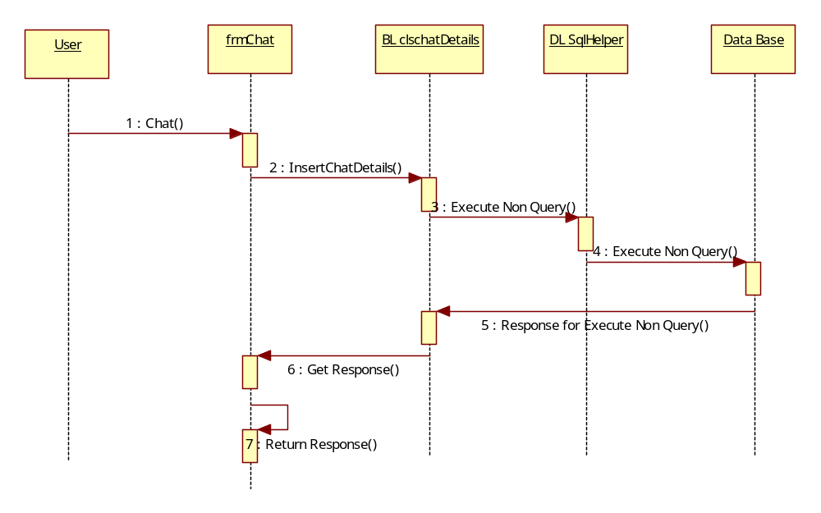
Collaboration Diagrams

Admin Login

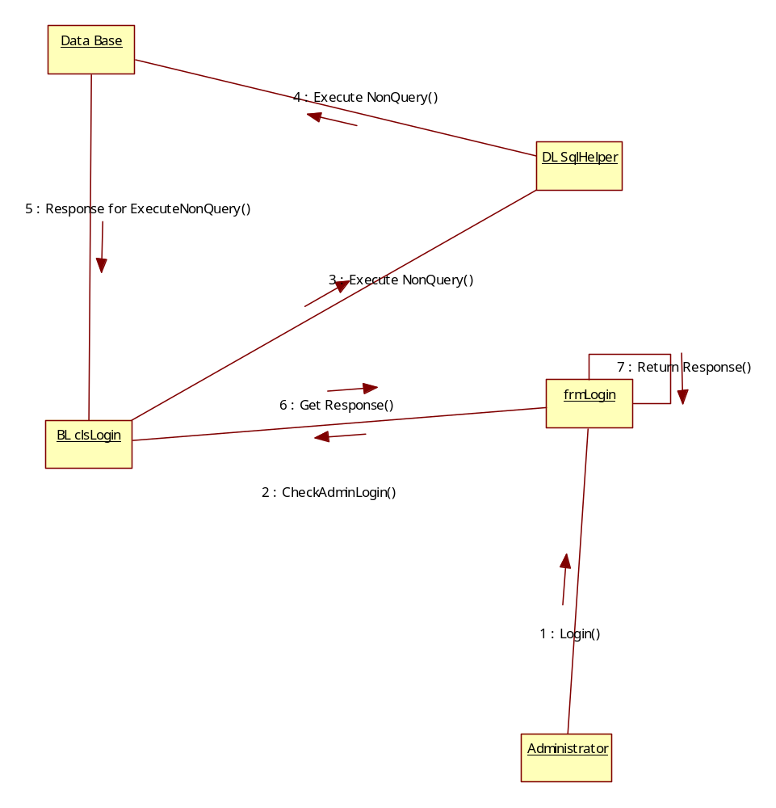
Admin Add New Country Details

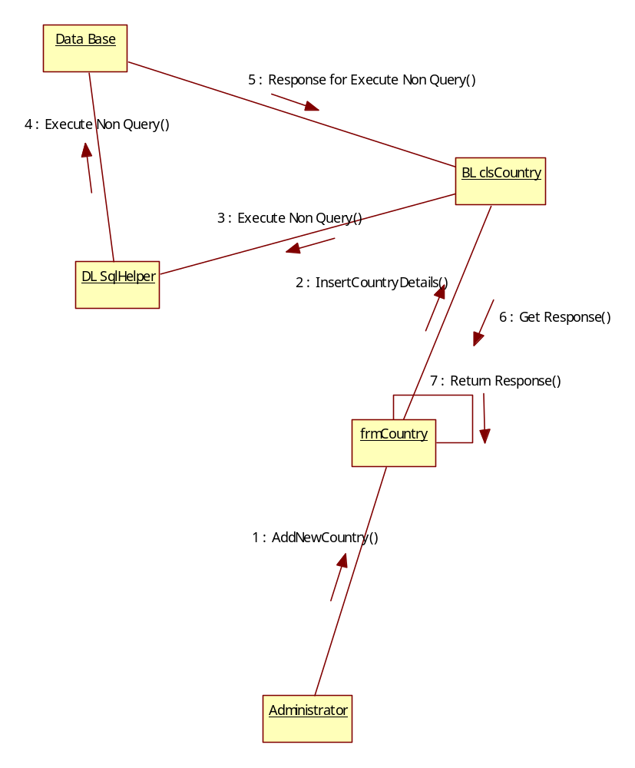
Admin Add New State Details
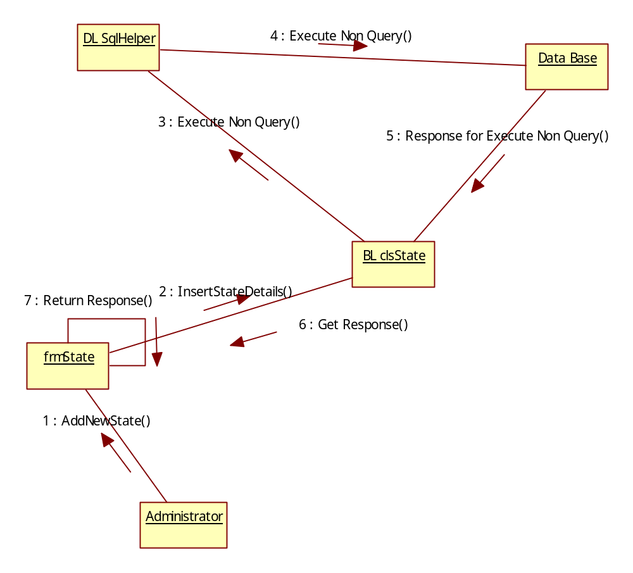
Admin Track User Login Details

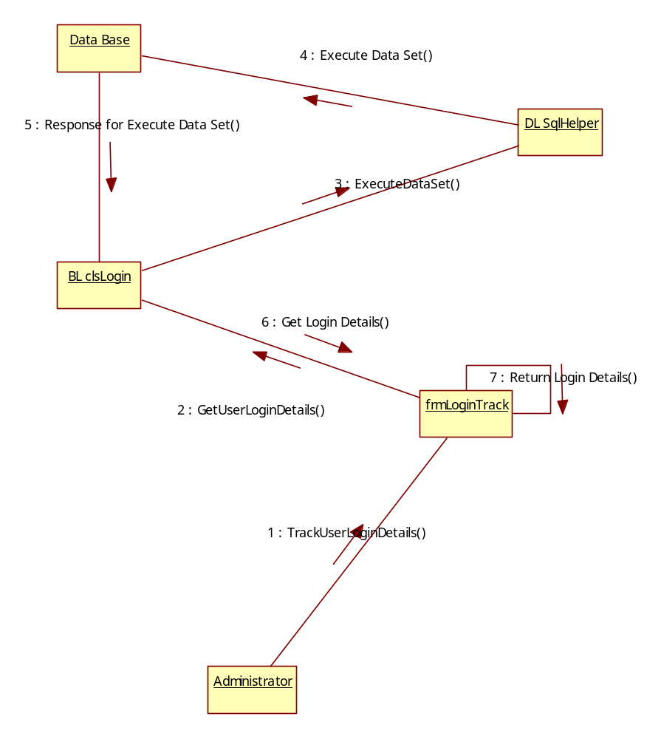
Admin Track User Log Out Details
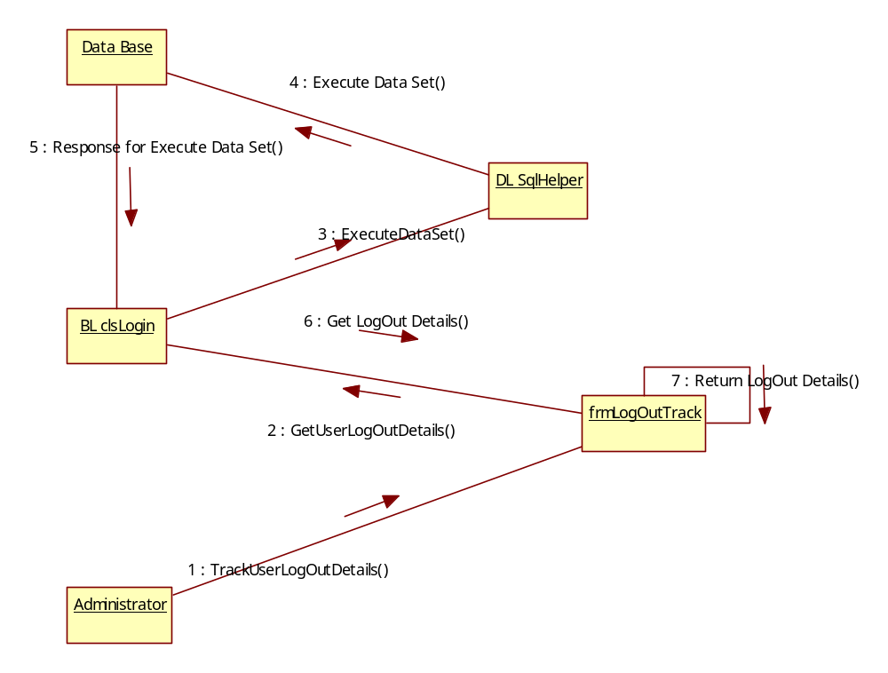

User Login

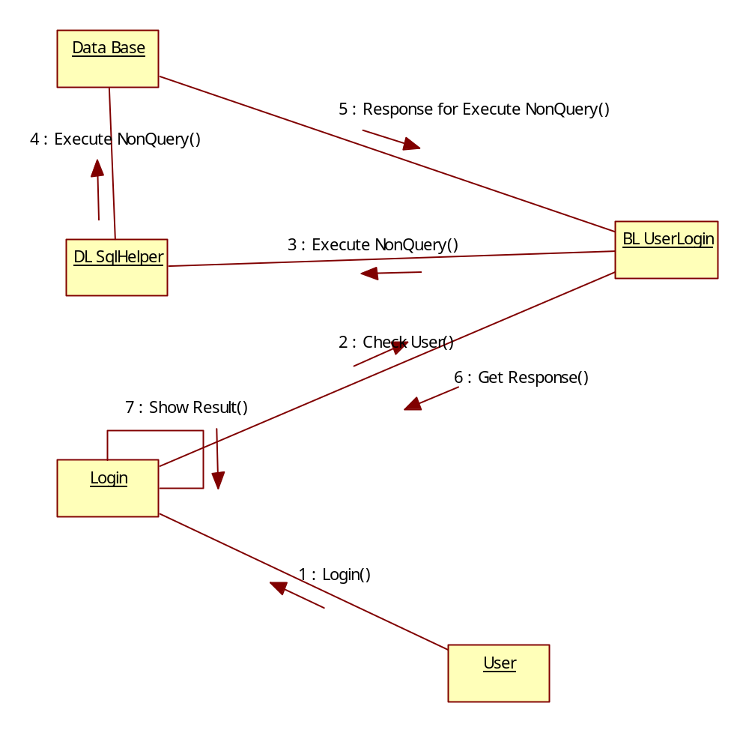
User Chat Details
